6. Understand how to access remote system using (VNC viewer, Anydesk, teamviewer and remote desktop connections)

**VNC Server:**

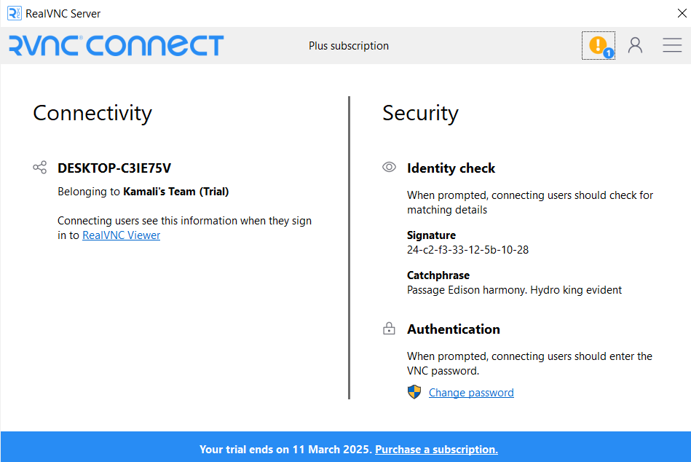

**Connected through Phone: VNC Viewer**



**Anydesk:**

**I have tried connecting windows from Linux**

**Windows Screen:**

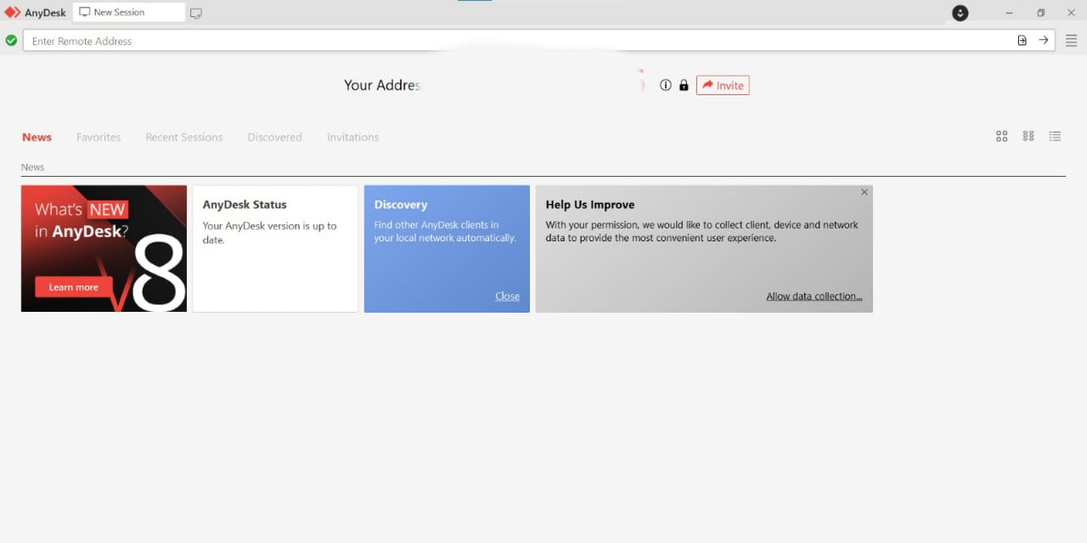

**Linux Screen:**

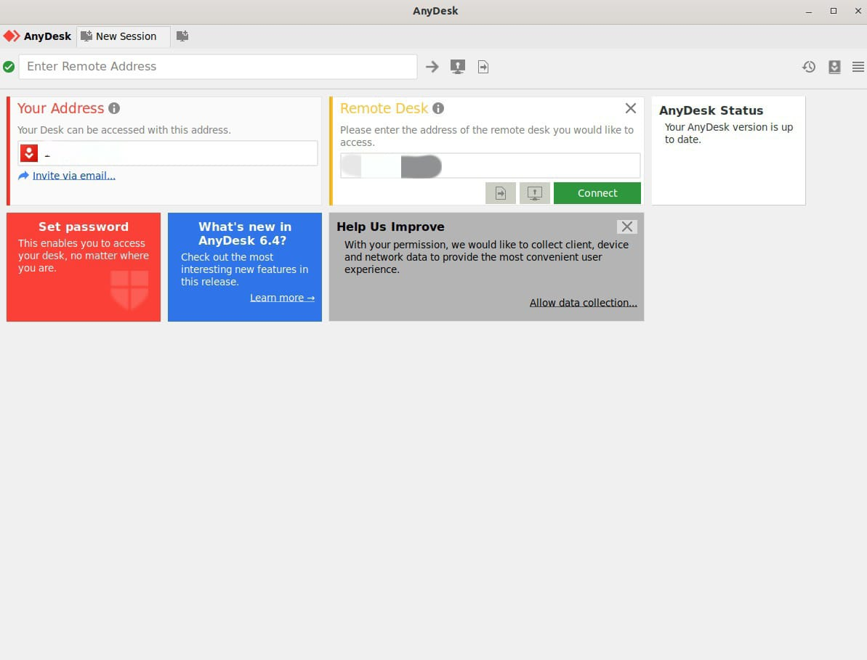

**Connection:**

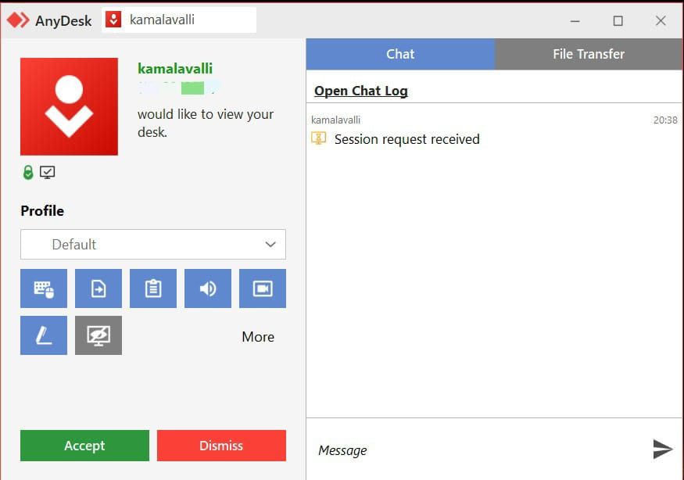

**Team Viewer:**

**Linux Screen:**

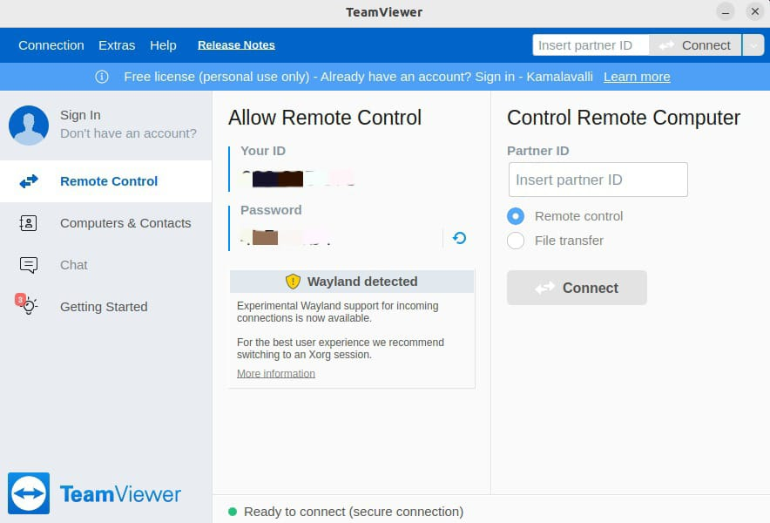

**Windows Screen:**

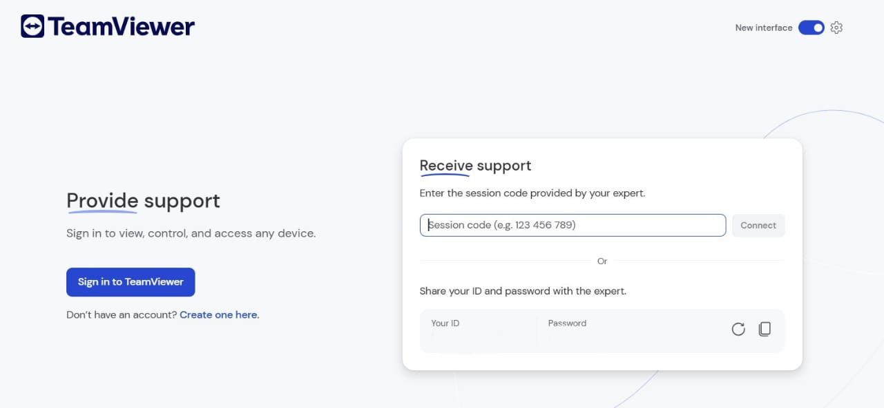

**Remote Desktop Connection:**

**Linux terminal:**

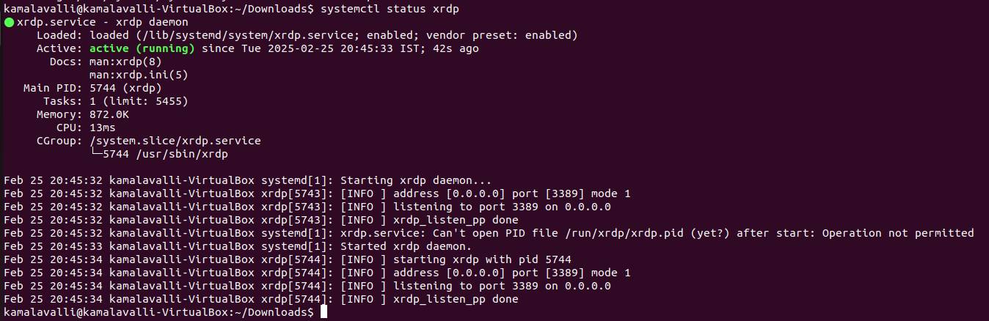

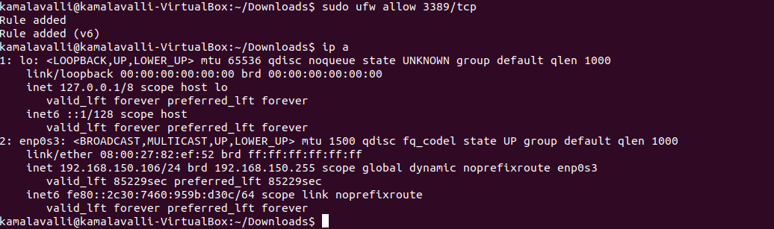

**Windows:**

